**Tensorflow notes**

Machine Learning is divided into 3 parts

-Supervised Learning

-Unsupervised Learning

-reinforcement Learning

Supervised Learning - Labels

---Classification Problem -

---Regression Value - historical data

Unsupervised Data - Cluster the group of data

Need Domain knowledge

Reinforcement Learning - Trial and Error

-Agent -Environment -Actions

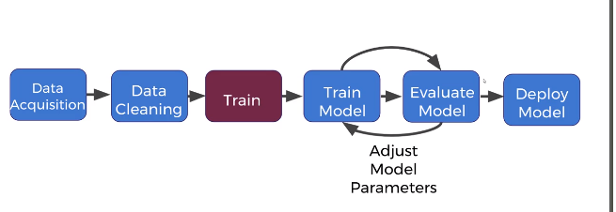

Data acquisition -

Data Cleaning - Most of the time split